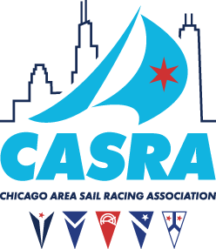

**CASRA CASUAL RACES**

**NOTICE OF RACE AMENDMENT NO. 1**

**POSTED AUGUST 6, 2017**

Power-driven winches and mechanical and electro-mechanical steering devices are permitted.

This changes RRS 52.